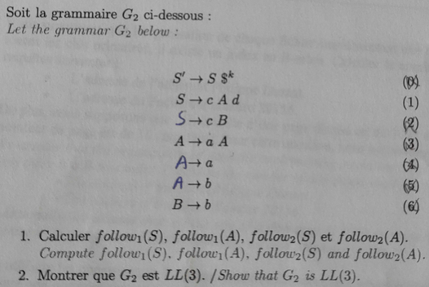

follow1(S) = {$}

follow1(A) = first1(d follow1(S)) U __first1(λ follow1(A)__) = {d}

follow2(S) = first2($² follow2(S)) = {$$}

follow2(A) = first2(d follow2(S)) U first2(λ follow2(A))

= d.first1(follow1(S)) U __follow2(A)__ = {d$}



– LL(1) ?

* 1 - lookahead(S -> cAd)

= first1(cAd follow1(S)

= {c}

* 1 - lookahead(S -> cB)

= first1(cB follow1(S))

= {c}

intersection non vide des lookahead donc pas LL(1)

– LL(2) ?

* 2 - lookeahead(S -> cAd)

= first2(cAd follow2(S)

= c.[first1(aAd) U first1(ad) U first1(bd)}

= {ca,cb}

* 2 - lookeahead2(S -> cB)

= first2(cB follow2(s))

= c.(first1(b))

= {cb}

intersection non vide des lookahead donc pas LL(2)

– (faire la même pour LL(3)

pas d'intersection donc LL(3)

